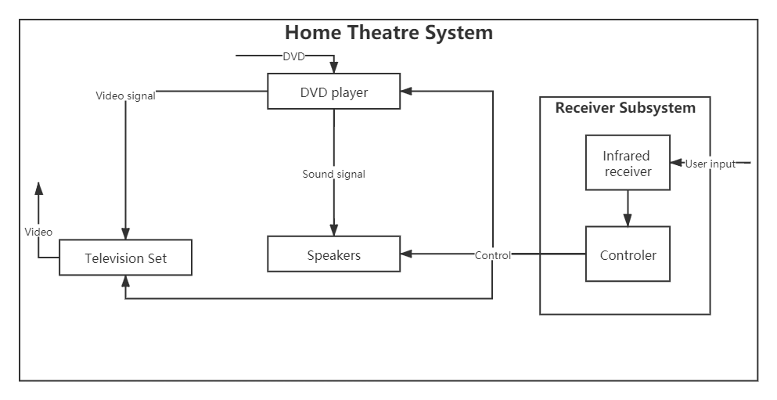

inputs to this system: video data in DVD

outputs: television set

inputs and outputs for the receiver subsystem?

inputs: user’s action

outputs: control signal

Do these inputs and outputs conform to the links connected to the receiver in your system diagram?

yes